Assignment #3

**Introduction:** We chose four websites Facebook, Instagram, Adroll and MailChimp. In first section we will discuss about login page and in second page we will discuss about sign up pages of these websites. The first two websites are social media platforms, whereas other two are related to different things. As, Adroll is third party agent for adds and Mailchimp is a creative way to create Email campaigns.

**Section 1:**

**Facebook V/S Instagram Sign in** **page:**

Facebook and Instagram Login improves user experience by enabling customers to easily sign in with filling in username/password. Facebook and Instagram have different set of layouts. Facebook uses Header Boxed with polaroid Layout; however, Instagram uses the grid layout for its users. Facebook utilizes whole area. Whereas, Instagram just uses central length. Both have option for creating new ID which makes page user-friendly. Facebook use style tag and different sets of classes and objects for formatting. Whereas, Instagram use .css(Cascade Style Sheet) file for formatting.

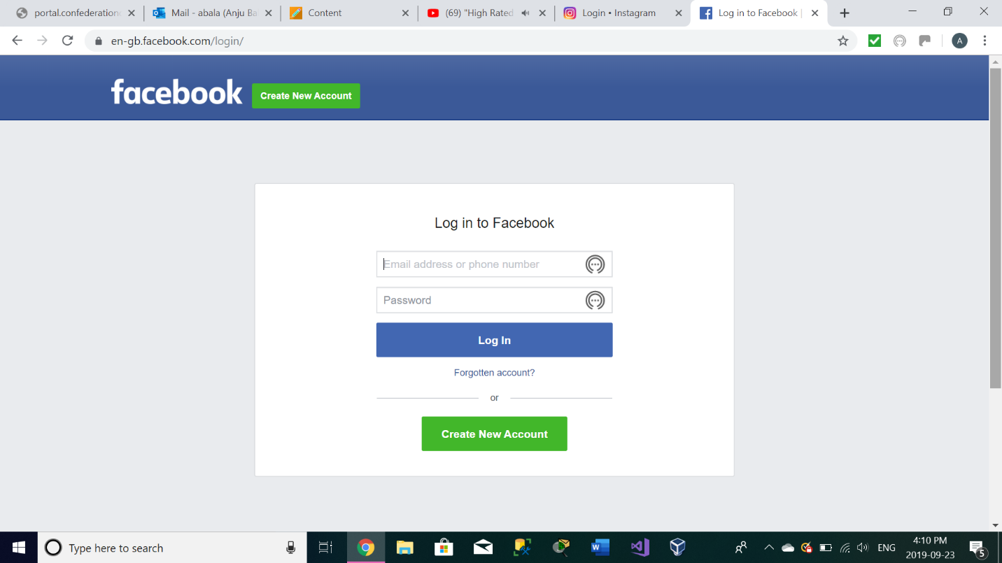

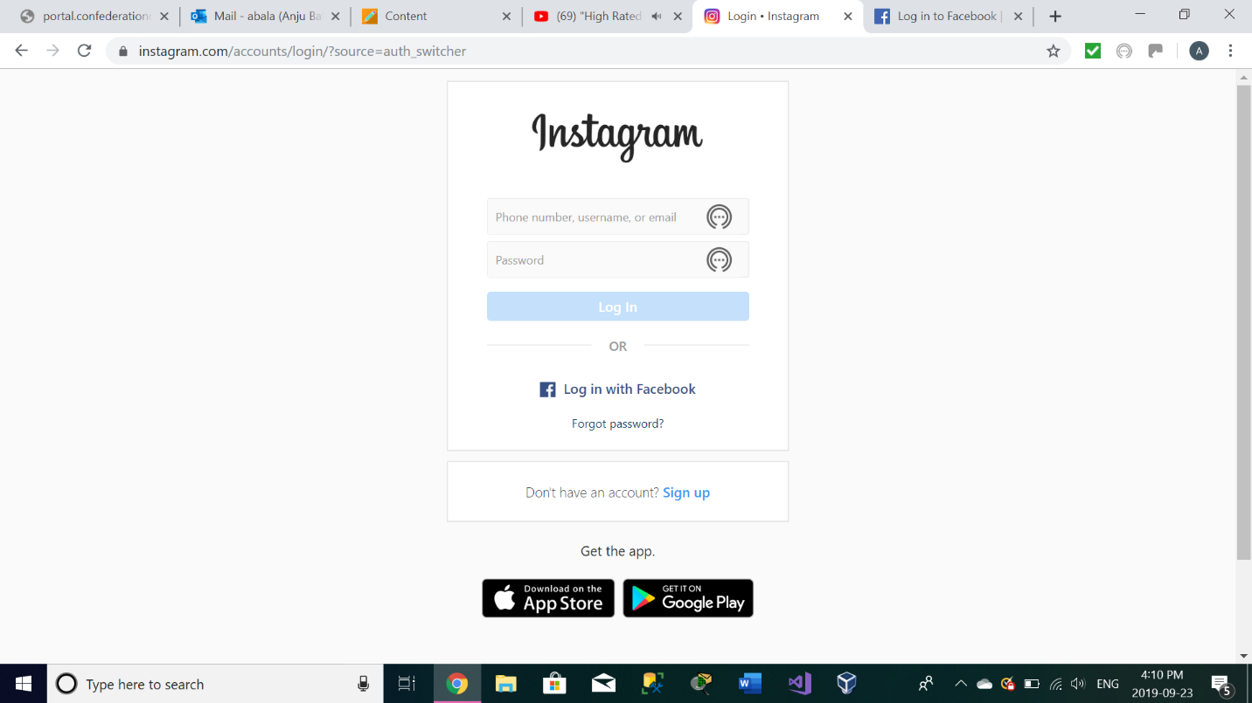

**Adroll:**

Adroll also acquires same set of fields as Facebook and Instagram. The only difference I found in that is it uses JavaScript for coding.

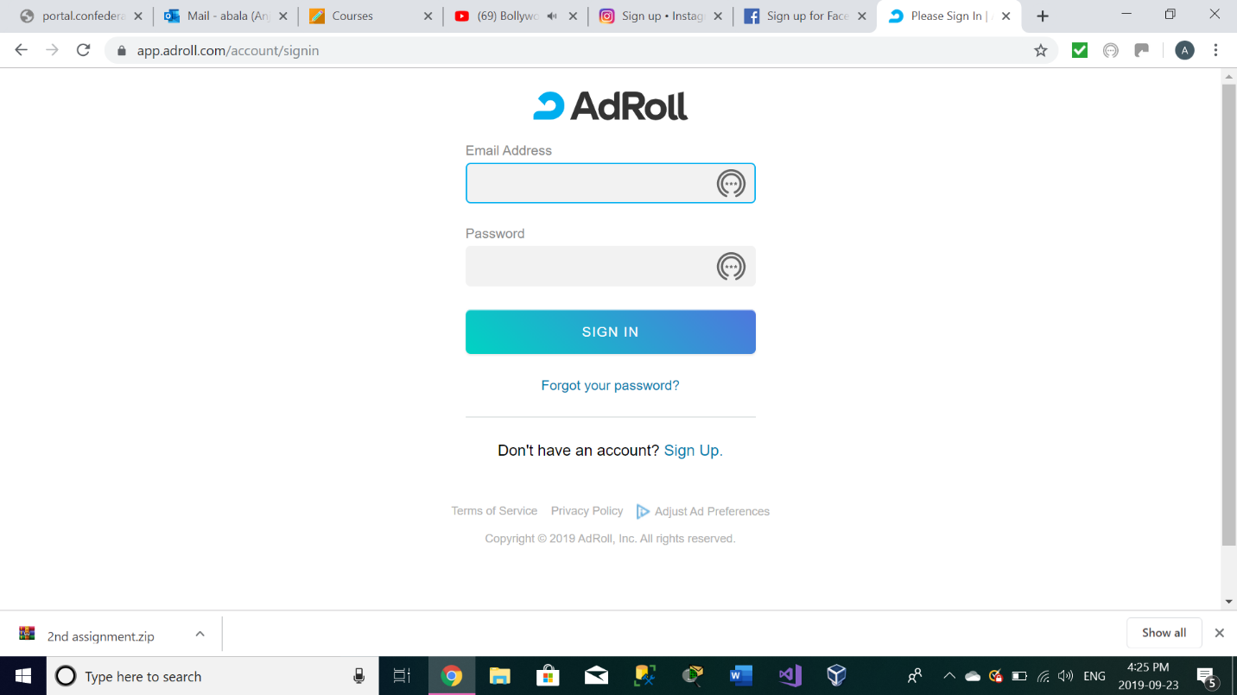

**MailChimp:**

MailChimp use Header Left Pane layout for its page loading. It uses style tag with .css files for formatting. MailChimp it has one field “Keep me logged in” i.e. a checkbox which can be quite time saving for its user, as if it is checked while logging in, it will remain same unless and until user intentionally logs out of the profile. It also fills the remaining section which it fills with a picture and a video hyperlink to watch a video, so that users can understand exactly what MailChimp is used for.

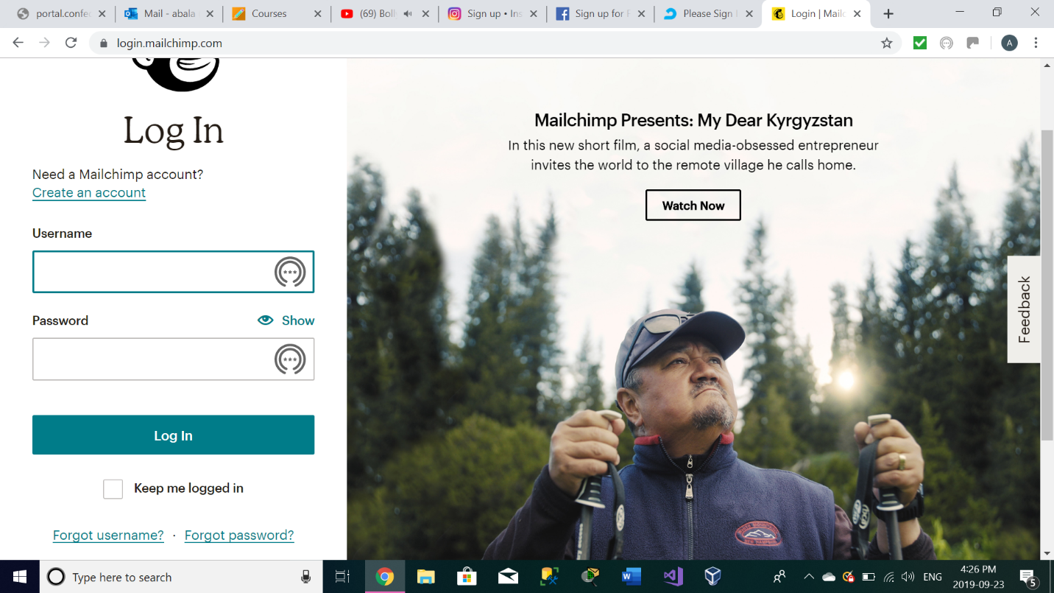

There is one thing in common in all sites, which is denoted as a logo of an eye beside text “show”. This small logo represents a functionality which can reveal the hidden password to double check if user is filling it accurately or not.

**Facebook:**

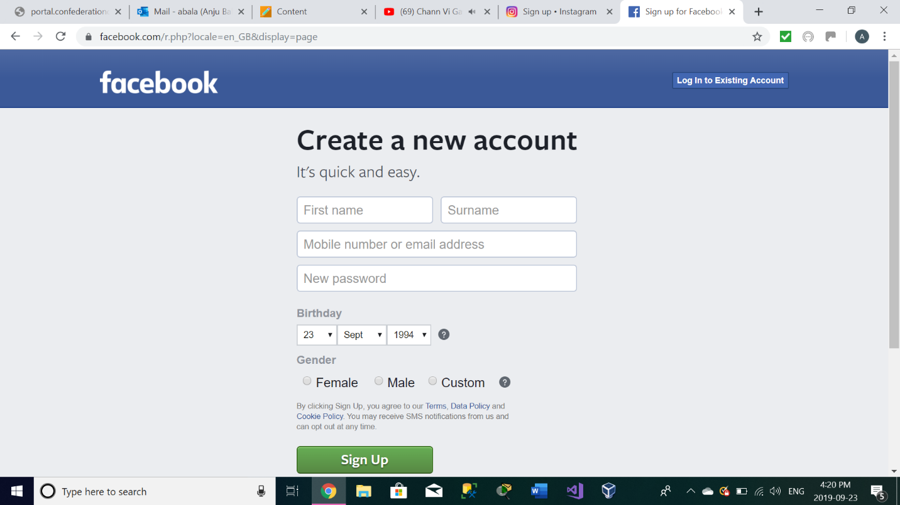

Pros:

* can login to existing account
* birthday field – it validates whether a person is adult or not
* universally accepting the third category of gender

cons:

no on-click signup option from different websites

**Instagram:**

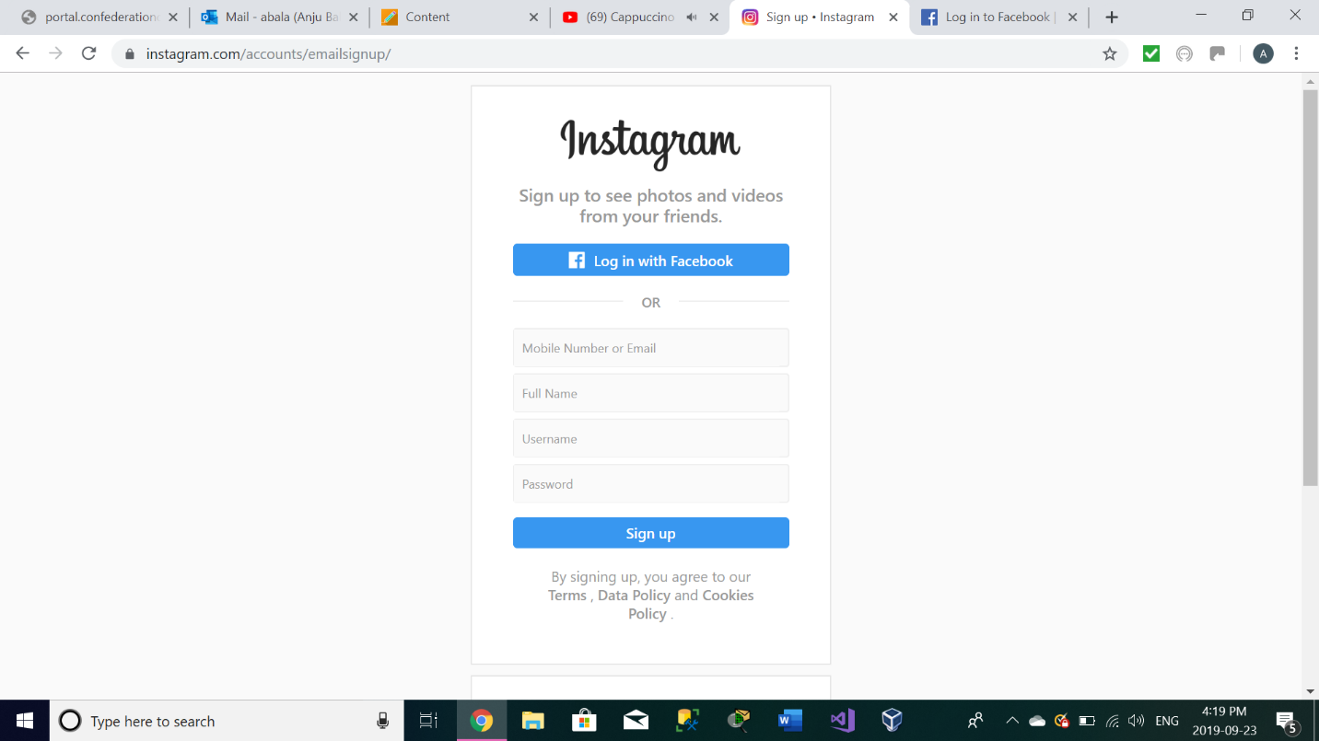

Pros:

* One can sign up with Facebook
* Easy to signup
* Simple

Cons:

* Page is not attractive

**Mailchimp:**

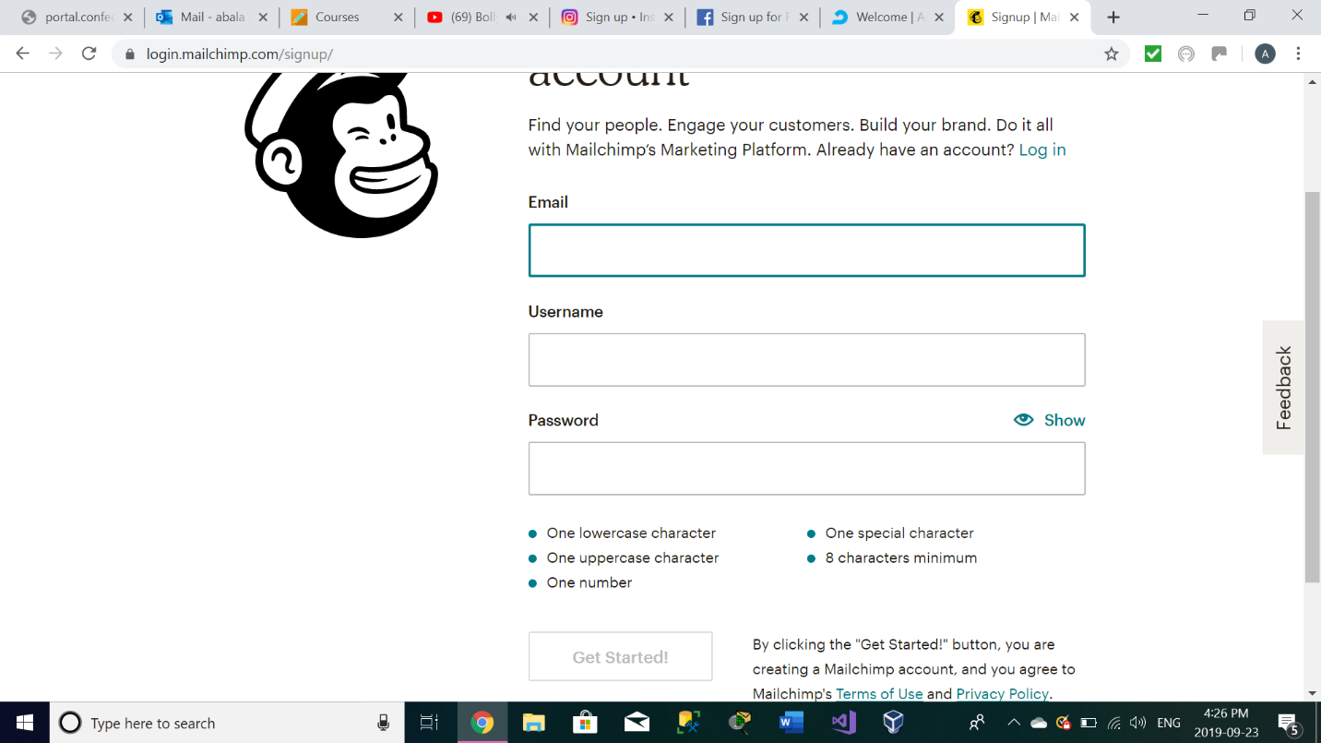

* **Username:** Do your users really need a username to sign up? Or can you just ask for their email, and then let them determine their username once they’ve logged in?
* **Confirm password:** This field is outdated and only necessary because of password masking, another [impractical technique](https://www.nngroup.com/articles/stop-password-masking/).

Instead of using a “confirm password” field, allow users to see what they’re typing by unmasking the original “password” field, or using a “show/hide” feature, the way MailChimp does on [their signup page](https://login.mailchimp.com/signup/).

Also, it suggests password and also indicate how much requirement of the password is fulfilled.

**Adroll:**

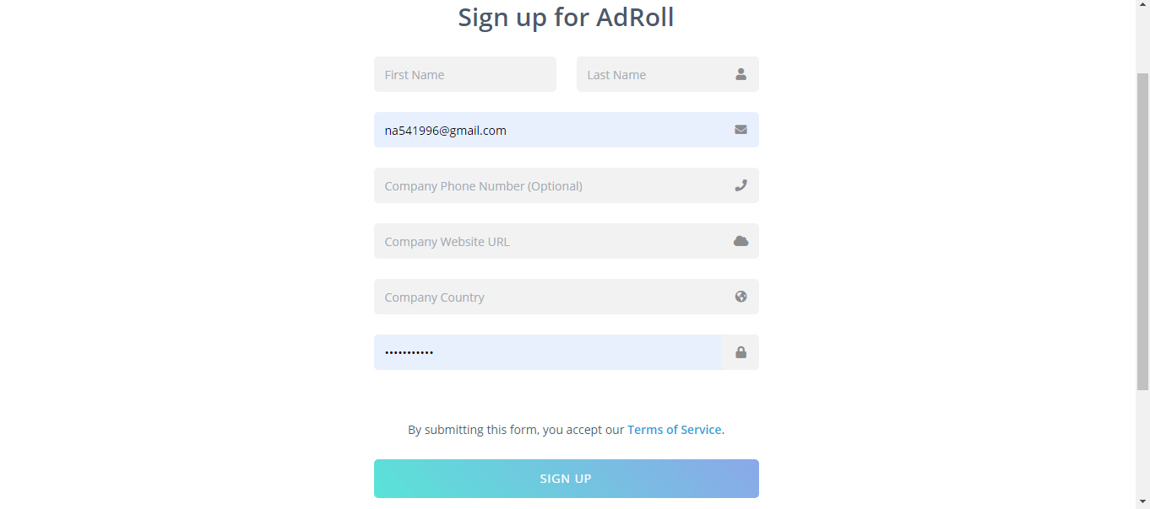

**Cons:**

Too much detailed information is asked

Pros:

Having icons for the fields